**MIS 381N**

**Stochastic Control and Optimization Homework 3**

**Jushira Thelakkat (jt39634)**

|  |
| --- |
| **Problem 1:**  **Use the branch and bound method to manually solve the following question.**    **Check using R. Check how many feasible solutions are there**  There are six feasible solutions  #Main |
|  |

#Branch 1.1

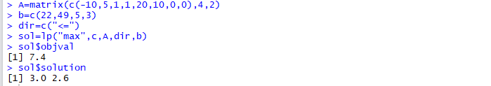

#Branch 1.2

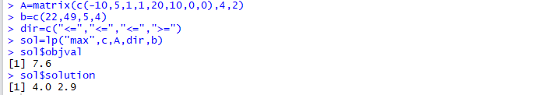

#Branch 1.1.1

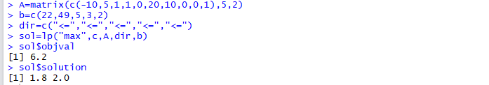

#Branch 1.1.2

Infeasible

#Branch 1.2.1

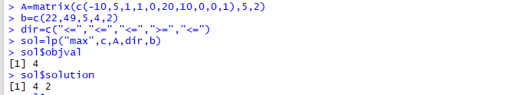

#Branch 1.2.2

Infeasible

#Branch 1.1.1.1

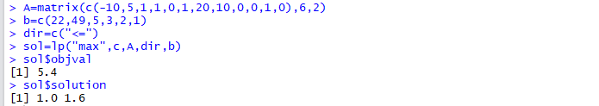

#Branch 1.1.1.2

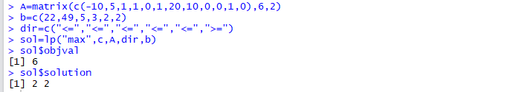

**What’s the difference between the number of branches and the number of feasible solutions**

There are 8 branches out of which 6 are feasible. Therefore, there are 2 infeasible solutions.

**Problem 2:**

**A company is thinking about building new facilities in Austin and Dallas. Here is the relevant data.**

Here, we are looking at 7 constraints –

Total investment less than 11 million (1);

Factories in Austin, Dallas and Warehouses in Austin, Dallas each less than 1 (4); Fa+Fd >=1 (1);

Wa+Wd <=1 (1)

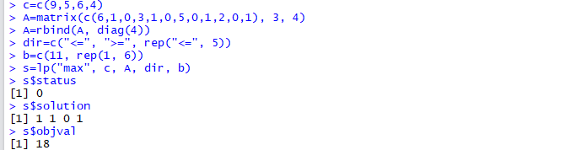

Therefore, the optimal strategy is to invest in 1 Factory each in Austin and Dallas and 1 Warehouse in Dallas giving us a maximum profit of 18 million.

**Problem 3:**

**Western Airlines wants to design a hub system in the United States. Each hub is used for connecting flights to and from cities within 1000 miles of the hub.**

We need minimum number of hubs. Our objective will thus be to minimize x1+x2+x3+……+x11+x12

Constraints will be the binary representation of the matrix given in the problem. 1 will replace all those cities that are within 1000 miles of the hub and 0 otherwise. Since each of the 12 cities should be included; I have made each of these constraints such that at least 1 city is included by each hub

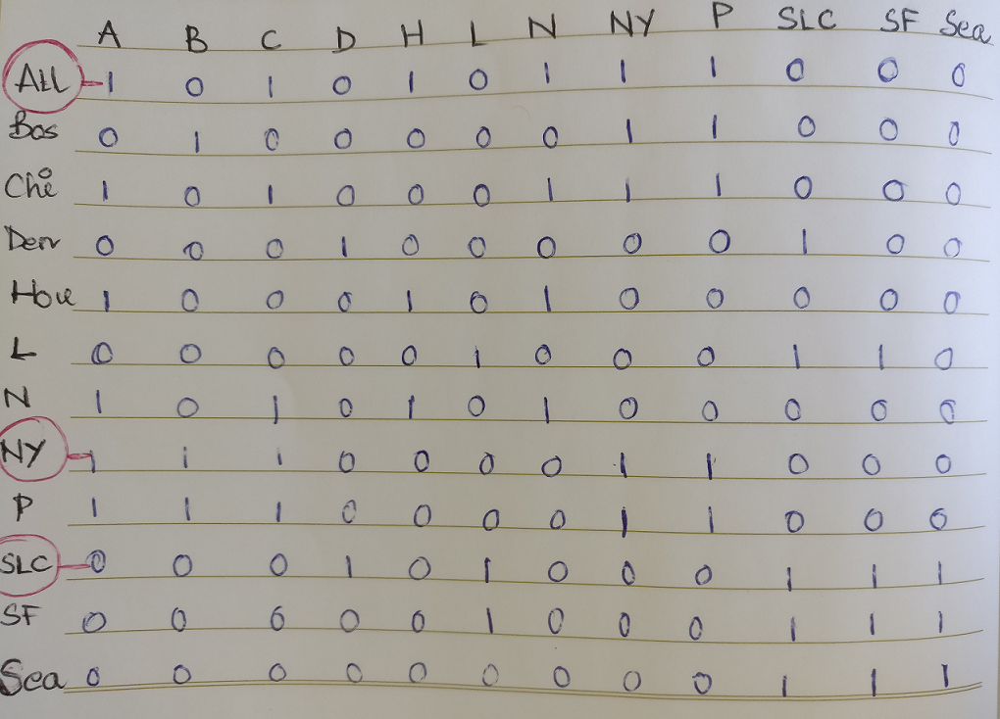

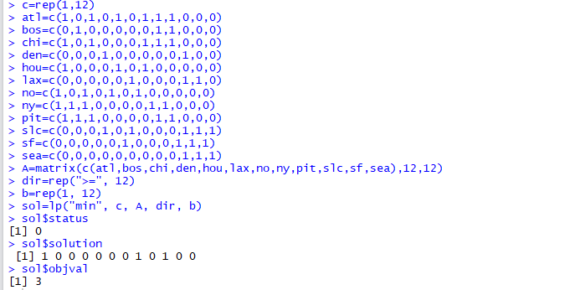

Therefore, hubs set up in Atlanta, NY and Salt Lake City will cover all the 12 cities.

The minimum number of hubs required is thus 3.

**Problem 4:**

**A paper mill cuts the rolls of paper into different widths to exactly satisfy customers’ demand. In this problem, assume the original rolls of paper are 120 inches wide. The table below shows the orders received by the paper mill.**

Here I have looked at different combinations of how the 120-inch rolls can be cut with the respective amounts of waste for each combination. The objective will be to minimize the waste and we will have three constraints will include the three quantities of the orders.

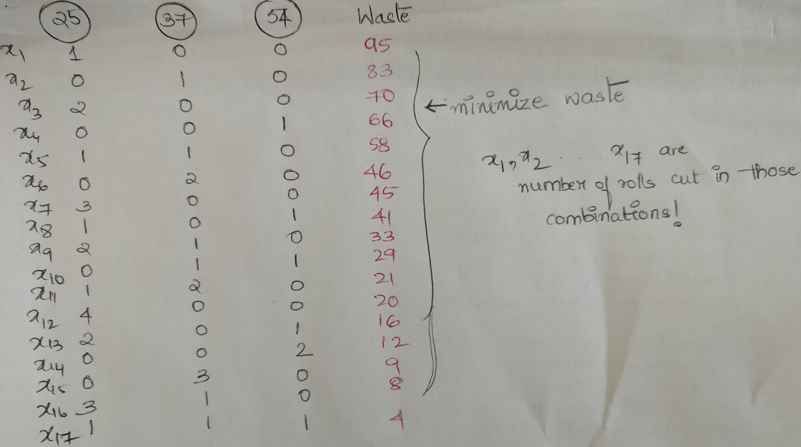

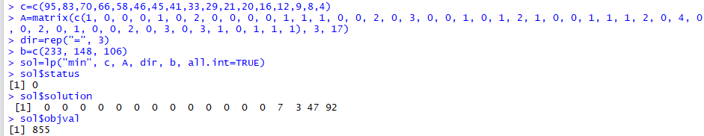

The optimal solution is:  
7 rolls cut into two 54-inch pieces; 3 rolls cut into three 37-inch pieces; 47 rolls cut into three 25-inch pieces and one 37-inch piece; 92 rolls cut into one 25-inch, one 37-inch, and one 54-inch piece

Wastage is 855 inches

**Problem 5:**

**The days-off scheduling problem must be solved routinely by businesses that operate 6 or 7 days a week. Examples include hospitals, airlines, municipal transportation companies, and the postal service. The most common example is the (5,7)-cyclic staffing problem. The objective of it is to minimize the cost of assigning workers to a 7-day cyclic schedule**

**Formulate an integer programming problem to represent this problem.**

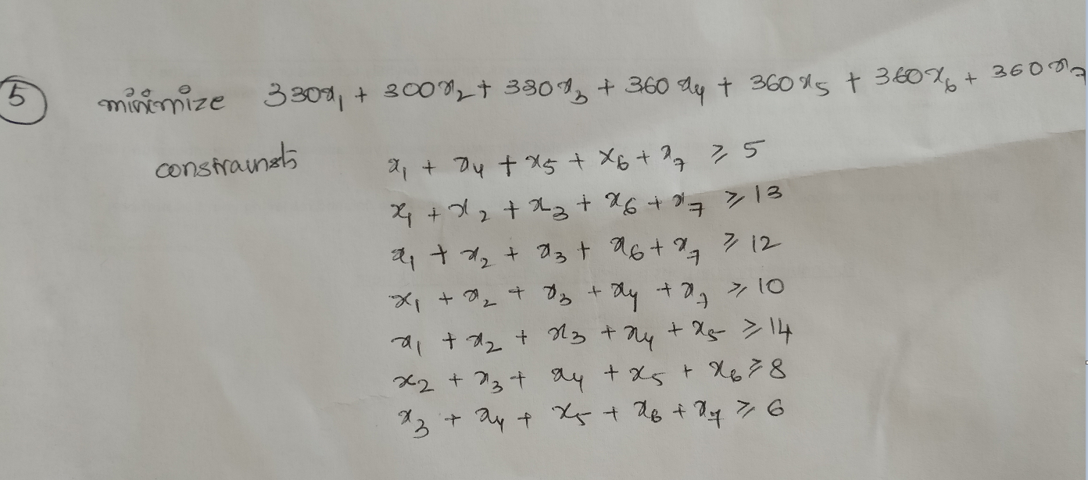

**Solve the problem in R.**

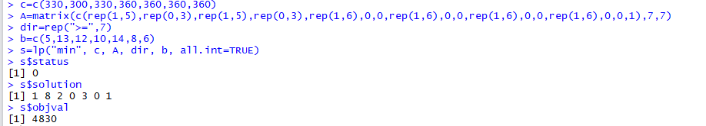

One person will work Sun-Thu; 8 people will work Mon-Fri; 2 people will work Tue-Sat; 3 people will work Thu-Mon; 1 person will work Sat-Wed. Cost is 4,830.

**What is the best working pattern?**

Monday to Friday is the most common work schedule.